FS1 Setup Manual

Flow Switch Controller and Pumps

HCT Chemigation System for Pressurized Water Systems
Golf Courses, Landscape, water pressure systems exceeding 60 psi

4.11.22

Description
The FS1 is a Switch Box, taking the signal from a flow switch or flow meter, then providing an on/off signal and or flow meter pulses which can then be relayed from the box to the chemical injection pumps for chemical pumping accuracy based on flow rates.

The pumps are designed to receive either an on/off signal to pump or not pump, or a variable signal to pump an appropriate amount of chemical based on the flow rate of the water. The pumps we recommend are designed for our / HCT’s aggressive acid and oxidizer chemistry – they operate at a low amount of chemistry necessary and the pressure of the water system.

The FS1 will operate up to three pumps. Each pump can be adjusted to deliver the precise amount of chemicals needed for HCT’s program plus an extra pig tail to operate perhaps a third pump for periodic or continuous fertilizer injection.

You’ll see below the FS1 is capable of being connected to a variety of flow switches and or flow meters so that a single FS1 is adaptable to a variety of pump stations, if not most/all.

One size fits all

FSC-1 has no maintenance components, can operate from one and up to three pumps, takes almost any flow switch or meter signal.

NOTE: If you are picking up pulses from the flow sensor, there is no need for an isolator. Most installs are a pulse flowmeter. The pulse output from the flow meter, or pump station, can go directly to the input on the FS1. It can use a 4-20 mA without an isolator, but it must be wired in a loop. Some people prefer to isolate it just in case. Regardless if using pulses, an isolator is not needed unless you are using a Data Industrial / Badger Flow meter. If so, see the page 4.

Technical Support – Please pre-arrange by appointment
Ontario, CA – PST Time Zone
Robert Bass – Developer Engineer - (480) 221-3128

Contents
Flowmeter Expectations: 4
For Use with Flow Switch: 5
For Use with a Pulse Flow Meter: 6
For Use with an Analog Flow Meter: 8
Pump Testing: 9
Priming The Pump(s): 9
Diagnostics & Alarms: 9
LMI PD Pump Settings Suggestions: 11
LMI PD Pump External Setting Guide: 11
LMI AD Pump External Setting Guide: 12
LMI B7/C7 External Setting Guide: 12
LMI B9/C9 External Setting Guide: 12
Walchem EWN External Setting Guide: 12
Wiring Diagram 1 14
Wiring Diagram 2 14
Wiring Diagram 3 15

Flowmeter Expectations:
- Analog (4-20mA) Signal Conditioner
Some flow meters require signal conditioners which may be necessary. Here is the isolator that we suggest SC6-1102. It is powered from the HCT controller.
https://www.automationdirect.com/adc/shopping/catalog/process_control_-a-_measurement/signal_conditioners/high_density_signal_conditioners/sc6-1102
To connect the Signal Conditioner to the Flow Switch Controller, do the following;
  - Connect Terminal # 7 of the Flow Switch Controller to Terminal # 5 of the SC6-1102 Signal Isolator.
  - Connect Terminal # 10 of the Flow Switch Controller to Terminal # 6 of the SC6-1102 Signal Isolator.
  - Connect the +4-20mA Output from the Pump Station to Terminal # 3 of the SC6-1102 Signal Isolator.
  - Connect the -4-20mA Output from the Pump Station to Terminal # 4 of the SC6-1102 Signal Isolator.

- Data Industrial/Badger Flow Meter
If your pump station is using the Data Industrial/Badger flow meter and this isolator is not installed in the Pump House control panel, you will need to acquire and install one. Data Industrial Optical Isolator Model A 1018-4026. Alternatively, a 2kΩ current limiting resistor may be used. To use the supplied 2kΩ current limiting resistor, do the following:
  - Connect one end of the resistor to Terminal # 7 of the Flow Switch Controller.
  - Connect the Black and Shield wire from the flow meter to Terminal # 8 of the Flow Switch Controller.
  - Connect the Red wire from the flow meter and the other end of the resistor to Terminal # 9 of the Flow Switch Controller.

- GF Signet Flow Meter
If you are using the GF Signet 3-2536-P[ ] paddlewheel flow meter, a 2kΩ pullup resistor must be used. To use the supplied 2kΩ pullup resistor, do the following:
  - Connect the Black Wire one end of the resistor to Terminal # 7 of the Flow Switch Controller.
  - Connect the Shield wire from the flow meter to Terminal # 8 of the Flow Switch Controller.
  - Connect the Red wire from the flow meter and the other end of the resistor to Terminal # 9 of the Flow Switch Controller.

For Use with Flow Switch:
On/Off pump activation
-See Wiring Diagram #1.

-Plug each of the metering pumps into the receptacles provided by the controller.
-Plug the power cord of the controller into a 120VAC GFIC outlet.
-Turn the Main Power switch to the On position.

From the home screen press the Menu Button, as shown in figure 1. Next press the Flow Meter Selection button, as shown in figure 2. Please note that some options shown in figure 2 are only for available depending on what settings have been made. The Flow Switch will need to be selected by pressing the Flow Switch Button, as shown in figure 3. Next press the Menu button again and select the Chem Feed Settings, as shown in figure 4. On the Chemical Feed Selection, press the Fixed Speed button, as shown in figure 5, then press the menu button and navigate back to the home screen. If the Pump switch is turned to the ON position, the pumps will turn on and run manually. With the pump switch in the Auto (A) position, the pumps will only run when flow is detected.

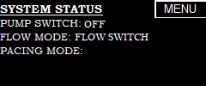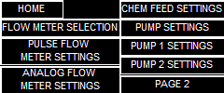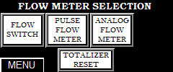
Figure 1. Home Screen Figure 2. Menu Screen Figure 3. Flow Meter
Selection Screen
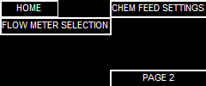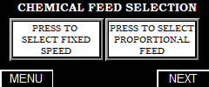
Figure 4. Menu Screen Figure 5. Chemical Feed Screen

For Use with a Pulse Flow Meter:
For a two (2) wire flow meter.
-see Wiring Diagram #2.
(If using a Data Industrial Flow Meter without an Isolator, flow the instructions on page 3. For a three (3) wire flow meter, see Wiring Diagram #3.)

-Plug each of the metering pumps into the receptacles provided by the controller.
-Plug the power cord of the controller into a 120VAC GFIC outlet.
-Turn the Main Power switch to the On position.

The metering pump(s) should have been set to external mode from the factory, if not they will need to be set to external mode.

From the home screen press the Menu Button, as shown in figure 1. Next press the Flow Meter Selection button, as shown in figure 2. Please note that some options shown in figure 2 are only for available depending on what settings have been made. On the Flow Meter Selection screen, the Pulse Flow Meter will need to be selected. Do this by simply pressing it. Press the Next button, as shown in figure 6, to be taken to the Flow Meter Settings screen. From the Flow Meter Settings screen and then select which type of meter it is, as shown in figure 7. If a Data Industrial or Badger flow meter is being used, select that by pressing the button. Once the button is pressed, the display will show two boxes that need information, as shown in figure 8. The K-Value and Offset can be found in the manual for the flow meter. These values are dependent on the pipe size and schedule. To enter these value, press the respective box, and a keypad will pop-up, as shown in figure 9. Enter the number by pressing the buttons, then press ENT. The CLR button will clear the value and the CAN will exit the screen and any value entered will be lost.

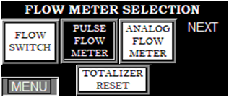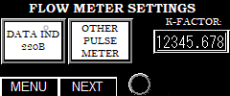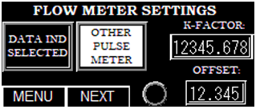
Figure 6. Flow Meter Figure 7. Flow Meter Figure 8. Badger Flow Meter
Selection Screen Settings Screen Settings Screen

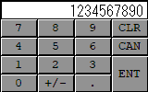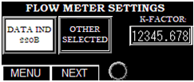
Figure 9. Numerical Keypad Figure 10. Other Flow Meter
Selection Screen Settings Screen

If a different brand flow meter is being used, select Other by pressing the button, as shown in figure 10. Once the button is pressed, the display will show one box that need information, as shown in figure 7. The K-Factor can be found in the manual for the flow meter and is dependent on the pipe size and schedule.

Once the Flow Meter Settings have been set, press the Next button to be taking to the Chemical Feed Selection, as shown in figure 4. If the pump will be pumping at a fixed speed when flow is detected, press the Fixed Speed button on the Chemical Feed Selection, as shown in figure 5, then press the menu button and navigate back to the home screen. With the pump switch in the Auto (A) position, the pumps will only run when flow is detected.

If the pump will be pumping proportional to the flow rate, press the Proportional button on the Chemical Feed Selection, as shown in figure 11. Press the Next button to be navigated to the Pump Settings screen. Select the amount of pumps that will be used, as shown in figure 12. Once the pump quantity has been selected, press the Next button to go to the Pump 1 Settings screen. On this screen you will select the brand pump being used, as shown in figure 13. If LMI is selected then press the Model Selection button to select the model being used, as shown in figure 14. Select the model pump being used and press the Exit button. Depending on the model selected, the Pump’s Max Output might auto fill. If it didn’t, this information as well as the desired PPM will need to be entered. If the Walchem is selected, the Pump Max Output and Desired PPM will need to be entered. If Other is selected, the pump’s maximum speed (stroked per minute) will need to be entered, as shown in figure 15.

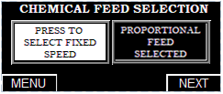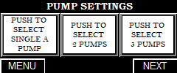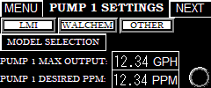
Figure 11. Chemical Feed Screen Figure 12. Pump Settings Screen Figure 13. Pump 1 Settings Screen

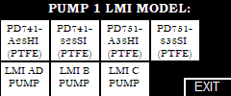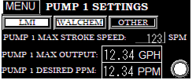
Figure 14. LMI Pump Figure 15. Other Pump
Settings Screen Selection Screen

If a second pump is being used, a NEXT button will be displayed in the top right corner. Press the next button to go to the next screen and repeat the above steps for the second and third pump, if applicable.

For Use with an Analog Flow Meter:
-For an analog loop powered flow meter
-see Wiring Diagram #3.

-Plug each of the metering pumps into the receptacles provided by the controller.
-Plug the power cord of the controller into a 120VAC GFIC outlet.
-Turn the Main Power switch to the On position.

From the home screen press the Menu Button, as shown in figure 1. Next press the Flow Meter Selection button, as shown in figure 2. Please note that some options shown in figure 2 are only for available depending on what settings have been made. On the Flow Meter Selection screen, the Analog Flow Meter will need to be selected. Do this by simply pressing it, then press the Next button to be taken to the Flow Meter Settings screen. Enter the maximum value for the flow meter for the given size pipe it is installed in. Often this can be located in the manual for the flow meter. To enter the maximum flow rate, click on the box with the flow rate and a numerical keypad will appear, as shown in figure 9. Once the value is entered, press the enter ENT button. CAN is cancel and will bring you back to the previous screen and clear any value that was entered and CLR is clear and will clear the value.

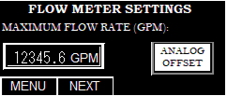
Figure 16. Flow Meter
Selection Screen

Once the maximum flow rate has been set, press the Analog Offset button, but make sure there is no flow in the pipe. This is used in the event that the analog signal from the flow meter at 0 GPM is not truly at 4.0mA. Once the Analog Offset button is pressed, press the Next button to be taking to the Chemical Feed Selection, as shown in figure 4. If the pump will be pumping at a fixed speed when flow is detected, press the Fixed Speed button on the Chemical Feed Selection, as shown in figure 5, then press the menu button and navigate back to the home screen. If the Pump switch is turned to the ON position, the pumps will turn on and run manually. With the pump switch in the Auto position, the pumps will only run when flow is detected, as shown in figure 6.

If the pump will be pumping proportional to the flow rate, press the Proportional button on the Chemical Feed Selection, as shown in figure 10. Press the Next button to be navigated to the Pump Settings screen. Select the amount of pumps that will be used, as shown in figure 12. Once the pump quantity has been selected, press the Next button to go to the Pump 1 Settings screen. On this screen you will select the brand pump being used, as shown in figure 13. If LMI is selected then press the Model Selection button to select the model being used, as shown in figure 14. Select the model pump being used and press the Exit button. Depending on the model selected, the Pump’s Max Output might auto fill. If it didn’t, this information as well as the desired PPM will need to be entered. If the Walchem is selected, the Pump Max Output and Desired PPM will need to be entered. If Other is selected, the pump’s maximum speed (stroked per minute) will need to be entered, as shown in figure 15.

If a second pump is being used, a NEXT button will be displayed in the top right corner. Press the next button to go to the next screen and repeat the above steps for the second and third pump, if applicable.

The metering pump(s) should have been set to external mode from the factory, if not they will need to be set to external mode.

Pump Testing:
Once the FS-1 has been fully programmed and proportional feed is being used, the pumps can be tested to verify that they are properly wired and receiving pulses. The pump switch must be in the AUTO position. From any screen press the Menu button, then press the page 2 button to be directed to the second page of the menu, as shown in figure 17. Press the Pump Test button to be taken the that respective screen, as shown in figure 18. Press the button for the pump that is to be tested. The test will send pulses to the selected pump for 1 minute. The light below the respective pumps button will also flash when the pulse is sent.

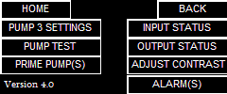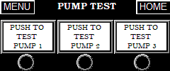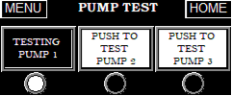
Figure 17. Menu Second Page Figure 18. Pump Test Screen Figure 19. Pump Test Screen

Priming The Pump(s):
Once the pumps have been properly and completely installed and FS-1 has been fully programmed and proportional feed is being used, the pumps can be tested to verify that they are properly wired and receiving pulses. The pump switch must be in the AUTO position. From any screen press the Menu button, then press the page 2 button to be directed to the second page of the menu, as shown in figure 17. Press the Prime Pump(s) button to be taken the that respective screen, as shown in figure 20. Press the button for the pump that is to be primed. This will send pulses to the selected pump for 5 minutes at a pulse rate of 100 pulses per minute (100 strokes per minute). The light below the respective pumps button will also flash when the pulse is sent.

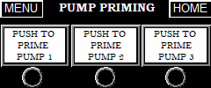
Figure 20. Pump Priming Screen

Diagnostics & Alarms:
The FS-1 has two screens for monitoring the inputs and outputs. From the second menu the Input or Output Status screens can be selected. To monitor the status of the inputs, press the Input Status button. You will now be taken to the status screen, as shown in figure 21. The light next to the Input’s name will be on, if the input is active. If a flow meter is being used, that light will blink with the pulses that are being received. If an analog flow meter is being used, the 4-20mA value will be displayed in the Analog Input.

To monitor the status of the outputs, from the Input Status screen, press the Outputs button to be taken to the Output Status screen. From the Menu’s second page, simply press the Output Status button. The light next to the Output’s name will be on, if the output is active. The light(s) for the pump(s) will blink when a pulse is sent to that pump.

Additionally, the respective status lights can be viewed on each pump setting screen, as well as the flow meter screen. Be advised that the lights for a pulse input or output can flash very fast and can be overlooked.

The FS-1 also can monitor the status of the analog signal, if an analog flow meter is being used. It is actively monitoring to detect if the flow meter has been disconnected or if there is an over current event. When either of these situations is detected, a warning symbol will blink on the Home screen. Press the menu button, navigate to the second screen of the menu and select the Alarm(s) button. The alarm screen will display the relevant alarm. If the analog input drops below 3mA, it will trigger the Flow Meter Disconnected alarm. This can be caused by a wire coming loose, disconnected, or something happening to the meter. If the unit detects the signal to be greater than 21mA, it will trigger the Over Current alarm. This can be error output from the flow meter set by the flow meter manufacturer or there could be an issue with the meter. The manual for the flow meter should help troubleshoot the over current situation.

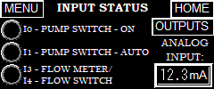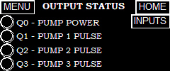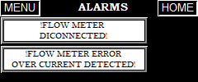
Figure 21. Input Status Screen Figure 22. Output Status Screen Figure 23. Output Status Screen

LMI PD Pump Settings Suggestions:
If using the LMI PD pump with the WaterSolv BC it is highly recommended that you enable the StayPrime™ function. This feature will run the pump for a desired amount of time if it has not run for a desired amount of time ensuring that the pump stay primed. This function is useful for the WaterSolv BC because of the potential for off gassing and causing a vapor lock.

This function should be enabled from the factory. If it isn’t, to enable this function, from the Home Screen, press the Menu Button while the pump is stopped. Then press the Left Button three times to select the StayPrime™ Degassing Technology Icon, . Press the Enter Button to view the StayPrime™ Degassing Technology Configuration, as shown in figure 18. StayPrime™ Degassing Technology is disabled by default.

When StayPrime™ Degassing Technology is enabled, the pump will run at 100% stroke rate for the set duration when powered on. The pump will return to its set operating mode and monitor itself for inactivity. Once the StayPrime™ Idle Timer has been reached (no strokes have occurred in the specified time), the pump will run at 100% for the StayPrime™ duration and return to its set operating mode. Select an Idle Timer based on the amount of time in which the pump may lose prime due to off-gassing of chemical. Select a Duration based on the time required to clear the suction line.

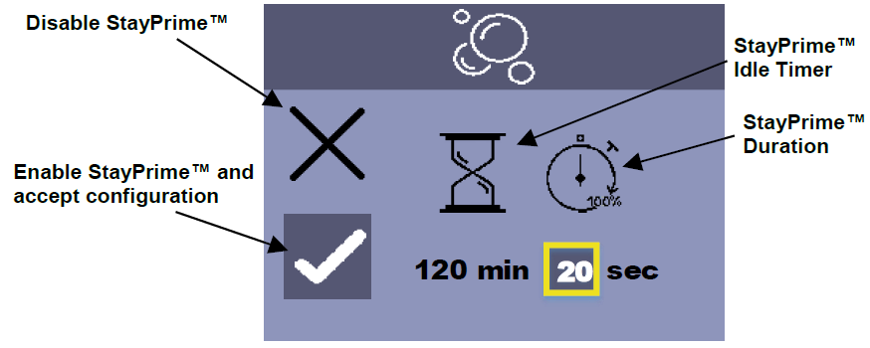

LMI PD Pump External Setting Guide:
With the home screen displayed and the pump stopped, press the Menu Button to enter the Settings Menu. Press the Right Arrow Button then press the Enter Button to enter the External Pulse Settings. The default is 1 incoming pulse is 1 output pulse, the Max = 100%, and the pulse width is 1ms. The default settings are perfect, so navigate so the cursor is on the Check Mark and press the Enter Button. After pressing the Enter Button it will exit to the Home Screen and will show the Pulse mode in the top left corner and press the Start Button to put the pump in standby mode waiting for pulses. The ring around the pumps current flow rate will be green.

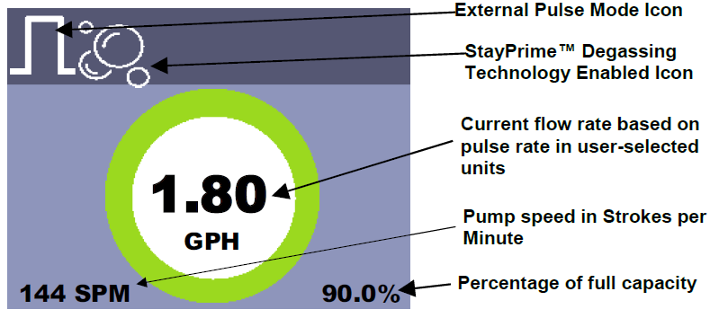

LMI AD Pump External Setting Guide:
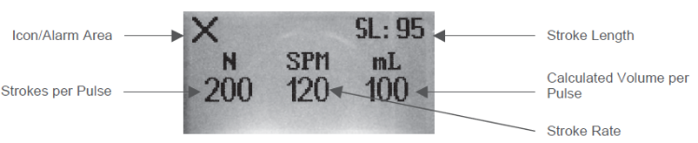
With the home screen displayed and the pump stopped/off (Power LED is off), press the Mode Button to enter the Settings Menu. Press the Down Button until the X (multiply symbol) is highlighted, then press the Power Button to enter the External Pulse Multiply Settings. The default is 1 incoming pulse is N=1. This means for each pulse input, the pump will pulse or pump one stroke. The default settings are perfect and press the Power Button. The Power LED will be illuminated and Amber in color. The pump is ready and waiting for pulses.
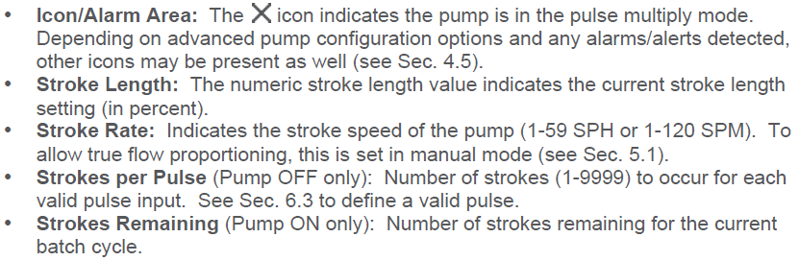
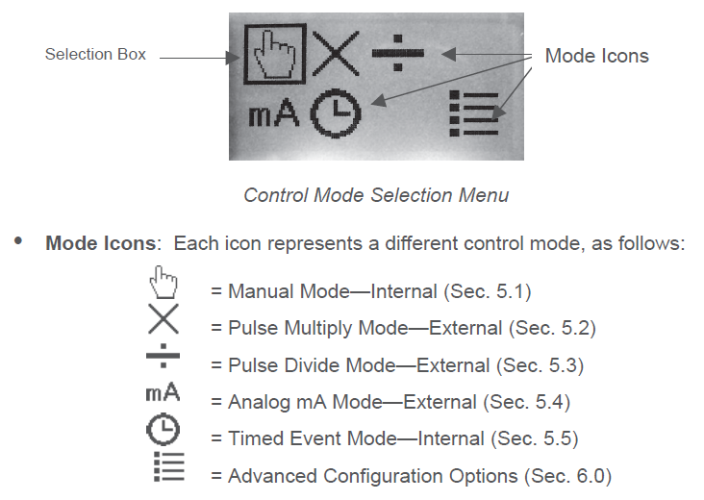

LMI B7/C7 External Setting Guide:
On the control panel there is a switch. Toggle the switch to the External position. The pump is now in the External position and waiting for pulses.

LMI B9/C9 External Setting Guide:
Start by pressing the Start/Stop Button to stop the pump. Press the Mod key and hold it for four (4) seconds. The LCD screen displays the last External mode that was programmed. If this is the first time the pump has been put in the External mode, the factory default will be displayed on the LCD screen. The factory default mode is “External Pulse Divide” with a divide value of one (1). The display will alternate between SPM and OFF. Next press and hold the Mode Key and the Start/Stop key for 5 seconds until the screen displays the multiply symbol “X”. This has a default multiply by 1, which is desired. Press the Start/Stop Button to put the pump in standby mode waiting to receive pulses.

Walchem EWN External Setting Guide:
Make sure the pump is in the WAIT condition. You can do this by pressing the START/STOP key until the pump starts pumping, then pressing it one more time. Using the UP/DOWN arrow keys, ensure the pump is set at 100%. Press the EXT key to get into the EXTERNAL Operation Mode. Press and Hold the EXT key for about 3 seconds to get to the External Selection Menu. Using the UP/DOWN arrow keys, scroll until “MULT” is displayed. Press the EXT key again. A number preceded by “X” will display. Default is “X 1”. Use the UP/DOWN arrow keys to change the multiplier to the desired setting. Press the EXT key to return back to the External Selection Menu (“MULT” displayed). Press the STOP/START key to back out and return to the External Operation Mode. The display will show “MULT” at the top and the programmed multiplier number in the main display. The pump is now operating in External Operation Multiply mode. As soon as it starts seeing pulse signals, the pump will begin pumping. For example, if your multiplier is set at 5, then the pump will stroke 5 times for every pulse signal it receives.

Wiring Diagram 1
Flow Switch

Wiring Diagram 2
Pulse Flowmeter (Data Industrial without Isolator)
Pulse Flowmeter (GF Signet 3-2536-P[ ])

Pulse Flowmeter (2-wire)

Wiring Diagram 3

